- The Bank of England's Monetary Policy Committee has stressed it needs to see underlying inflationary pressures cool further before it's ready to lower Bank Rate. So evidence that the downward momentum in pay growth eased in January, and labour market conditions remain tight, suggests we're unlikely to see a dovish shift in tone in the minutes of next week's meeting.
- Elsewhere, GDP rose in January, recovering most of the ground lost at the end of 2023. We expect lower inflation will underpin a gradual consumer-led recovery this year. The medium-term outlook remains subdued, but a report we published this week argued that reforming the UK's fiscal framework could boost the growth outlook while cutting government debt.
In its February policy statement, the Bank of England's Monetary Policy Committee stated that it would closely monitor indicators of resilience in the economy, as well as measures of labour market tightness and pay growth, when reviewing how long Bank Rate should be maintained at its current level. Therefore, this week's GDP and jobs market data for January promised to be key sources of information ahead of next week's MPC meeting.
The first of those, Tuesday's labour market release, won't have done much to allay policymakers' concerns that persistently high pay growth could prevent inflation from sustainably returning to the BoE's 2% target. Headline (three-month average of the annual rate) private sector regular pay growth, the MPC's favoured measure, eased only very modestly to 6.1% from 6.2% in December.
Wages are still growing at roughly double the pace that would be consistent with meeting the inflation target in the medium term. And our sentiment-based nowcast, developed in collaboration with Penta, indicates that pay growth is likely to remain at similar rates in the near term (Chart 1) – a result that is consistent with the findings from both the BoE's own Decision Maker Panel and a pay survey recently conducted by the BoE's regional agents.
Chart 1: Our nowcast suggests the downward momentum in pay growth has eased in early 2024
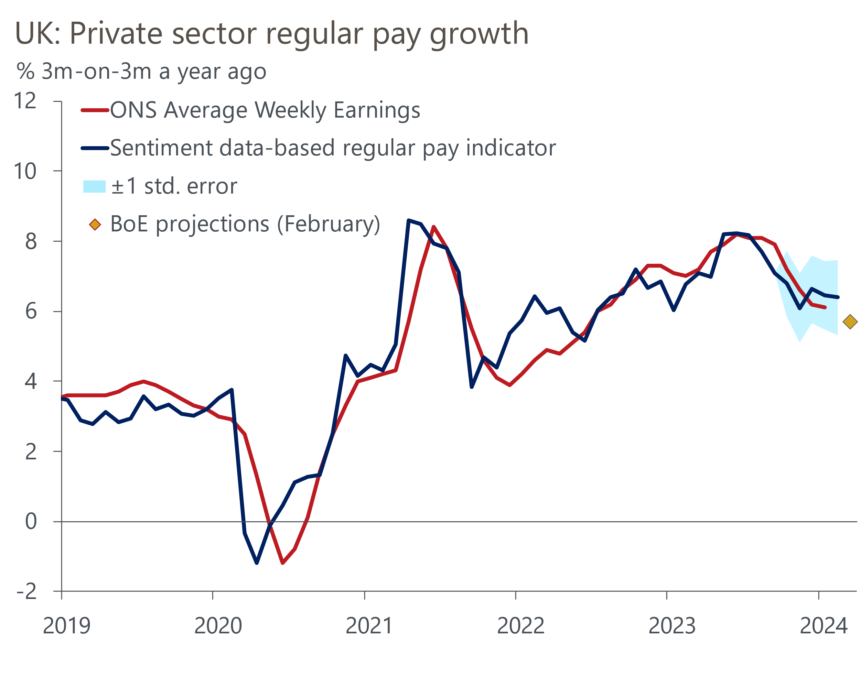
Sources: Oxford Economics, Haver Analytics, Penta
The jobs market release also included data from the Labour Force Survey, which was reintroduced last month following a five-month hiatus. While we place a relatively small weight on the new LFS estimates, given its ongoing problem with small samples, the latest survey suggested labour market conditions remained relatively tight by historic standards in the three months to January. Both employment and unemployment fell slightly on the previous three-month period, while inactivity rose.
A number of MPC members have suggested they need to see more evidence that measures of inflation persistence are cooling before considering voting for a rate cut. But it's unlikely they found that evidence in this labour market release. And with the committee having previously expressed its concern about the potential impact of April's large rise in the National Living Wage, we think the MPC is likely to maintain a relatively cautious tone in the minutes of next week's meeting as it waits for more evidence that underlying price pressures are abating.
GDP growth has not played a direct role in the MPC's decision making process in recent years, though it does bear on the strength of inflationary pressures. GDP rose by 0.2% m/m in January, recovering most of the ground lost at the end of last year. Particularly volatile data for the distribution sector was a key part of the story, with retail sales having rebounded in January following December's sharp fall. This development was complemented by rebounding activity in the health and construction sectors. We think the end of 2023 probably marked the low point for activity and 2024 should see a steady, but not spectacular, recovery take root. Much lower inflation will offer solid support to real household income growth, and together with some dissaving, this points to a steady consumption-led recovery.
Though the foundations are in place for a gradual pickup in activity, the medium-term outlook remains subdued. Dysfunctional fiscal policy is one of the causes, with last week's Budget highlighting many of the problems, including the poorly designed fiscal rules. Chancellor Jeremy Hunt laid out some of his longer term strategies to raise UK GDP growth when defending the Budget to the Treasury Select Committee this week, but there was no acknowledgement of any failings in the fiscal policy framework.
Labour seem to be committed to a similarly flawed approach. But we think there's a better way and we published a note this week that set out our proposals for overhauling the fiscal rules and implementing a more growth-friendly policy mix. We propose switching the deficit target to the cyclically-adjusted current budget; cutting the time horizon to three years from five; and removing the distortionary effects of Asset Purchase Facility losses from the debt rule. Simulations using our Global Economic Model indicate these changes could increase GDP by more than 1ppt over a 10-year horizon, while still lowering the debt-to-GDP ratio (Chart 2). Outcomes could be even better if the government also implemented a coherent supply-side strategy to boost potential output.
Chart 2: Better fiscal rules would result in stronger growth and keep the debt ratio falling
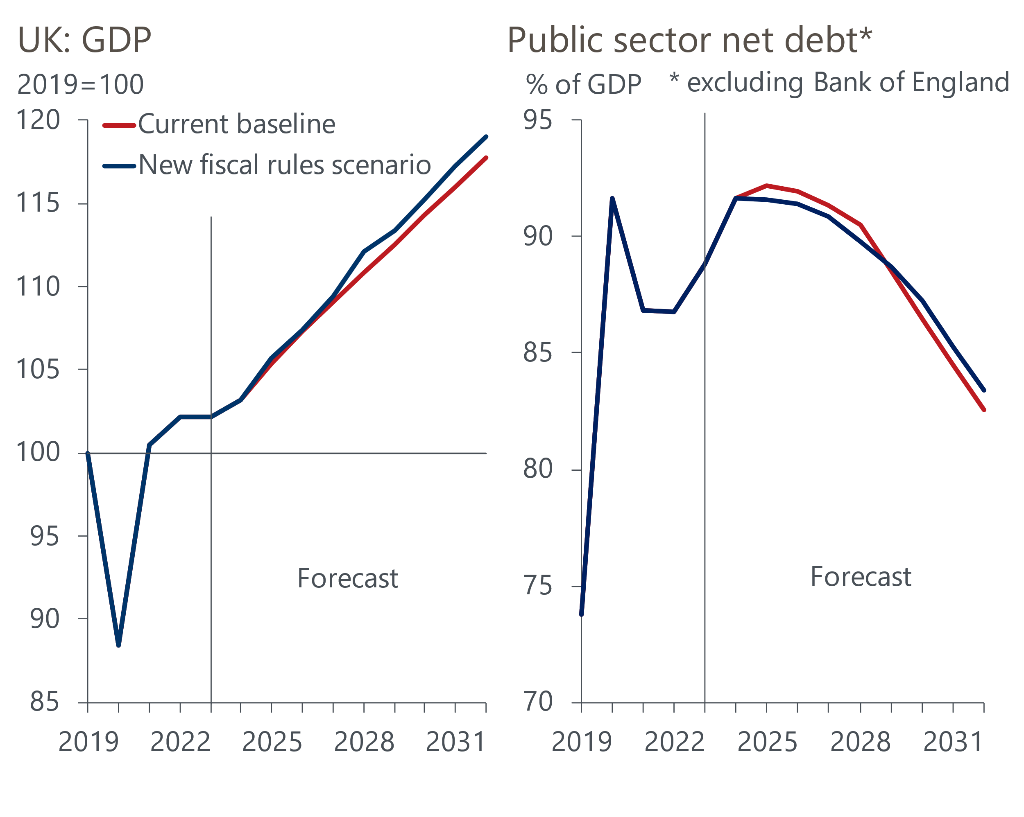
Sources: Oxford Economics, Haver Analytics

The week ahead
Next week's MPC meeting is likely to be the fifth in succession to keep Bank Rate unchanged at 5.25%. The committee has emphasised that further evidence of a sustained easing in core inflation and private sector pay growth would be required before it is ready to lower Bank Rate. But data released since the February meeting is unlikely to have moved the needle much on this front. Therefore, we expect the outcome and vote split of March's meeting to mimic February's, and our main focus will be on whether the minutes provide further forward guidance on the timing and pace of rate cuts.
CPI inflation held steady around the 4% mark in the previous three releases, but February's data should see a renewed easing in price pressures. Base effects are likely to be the main factor, with both the food and core components having seen large m/m increases last February. As a result, CPI inflation in February is forecast to come in at 3.5%.
Next week will also see the release of February's public finances data. February's deficit should shrink on a y/y basis given spending was boosted in February 2023 by energy support payments. Therefore, we think public sector net borrowing (excluding banks) was £5.4bn in February.
Retail sales have been incredibly noisy in recent months, with the Office for National Statistics claiming this is in part due to a shift in seasonal spending trends around Black Friday and Christmas. January's sharp rise in sales reversed December's surprisingly large drop. But January's strength was partly due to fuel sales rebounding to a very high level that is unlikely to be sustained. So we expect a drop in fuel sales to drive a 0.2% m/m decline in retail sales in February.
Finally, the forward-looking balances in February's S&P Global PMI surveys suggest the gap in sectoral performance may have widened in March. The manufacturing survey reported that new orders sank to a four-month low, so we think March's flash manufacturing PMI may fall slightly to 47.3. In contrast, February's services survey suggested that improved customer demand drove a marked rise in new orders, particularly from abroad. As a result, the flash services PMI is forecast to come in at 54.1 in March, and this would leave the composite PMI at around 53.3.
Table 1: Week ahead calendar
Date | Events | Period | Measure | Unit | Previous | Forecast
Mar 20 | CPI inflation | Feb | m/m | % | -0.6 | 0.7
Mar 20 | CPI inflation | Feb | y/y | % | 4.0 | 3.5
Mar 20 | RPI inflation | Feb | m/m | % | -0.3 | 1.0
Mar 20 | RPI inflation | Feb | y/y | % | 4.9 | 4.8
Mar 20 | Producer input prices | Feb | m/m | % | -0.8 | -0.2
Mar 20 | Producer input prices | Feb | y/y | % | -3.3 | -3.0
Mar 20 | Producer output prices | Feb | m/m | % | -0.2 | 0.2
Mar 20 | Producer output prices | Feb | y/y | % | -0.6 | 0.1
Mar 21 | Public finances | Feb | PSNB ex | £bn | -16.7 | 5.4
Mar 21 | S&P Global/CIPS manufacturing | Mar | PMI | % bal | 47.5 | 47.3
Mar 21 | S&P Global/CIPS services | Mar | PMI | % bal | 53.8 | 54.1
Mar 21 | S&P Global/CIPS composite | Mar | PMI | % bal | 53.0 | 53.3
Mar 21 | BoE Bank Rate decision | Mar | Bank Rate | % | 5.25 | 5.25
Mar 22 | Retail sales inc fuel | Feb | m/m | % | 3.4 | -0.2
Mar 22 | Retail sales inc fuel | Feb | y/y | % | 0.7 | -0.7
Source: Oxford Economics

Key forecasts
Table 2: UK forecast overview
(Annual percentage changes unless specified)
 | 2022 | 2023 | 2024 | 2025 | 2026 | 2027
GDP | 4.3 | 0.1 | 0.5 | 2.0 | 2.0 | 1.6
Private consumption | 4.8 | 0.3 | 0.9 | 2.6 | 2.2 | 1.6
Fixed investment | 8.0 | 2.9 | -3.4 | 1.0 | 2.8 | 2.1
Government consumption | 2.3 | 0.6 | 3.9 | 2.3 | 1.5 | 1.5
Exports of goods and services | 9.0 | -1.4 | -1.0 | 2.8 | 2.4 | 1.7
Imports of goods and services | 14.6 | -1.6 | 1.2 | 3.5 | 2.9 | 1.9
Industrial Production | -3.5 | -0.3 | 0.2 | 0.9 | 1.5 | 1.2
Consumer prices | 9.1 | 7.3 | 2.2 | 2.1 | 2.3 | 2.2
Unemployment rate (%) | 3.9 | 4.0 | 4.0 | 3.9 | 3.8 | 3.7
Current a/c balance (% of GDP) | -3.1 | -2.8 | -2.9 | -2.9 | -3.0 | -2.9
Government balance (% of GDP) | 4.4 | 5.0 | 3.2 | 2.8 | 2.0 | 1.3
Cen. bank policy rate (%, EOP) | 3.50 | 5.25 | 4.50 | 3.50 | 2.50 | 2.00
10yr govt. bond yield (%, EOP) | 3.67 | 3.54 | 3.82 | 3.47 | 3.01 | 2.85
Exchange rate (US$ per £, EOP) | 1.20 | 1.27 | 1.27 | 1.29 | 1.32 | 1.35
Exchange rate (euro per £, EOP) | 1.13 | 1.15 | 1.17 | 1.16 | 1.15 | 1.15
Source: Oxford Economics
Table 3: Quarterly forecasts for the UK
 | 2023 |  |  |  | 2024
 | Q1 | Q2 | Q3 | Q4 | Q1 | Q2 | Q3 | Q4
GDP (% year) | 0.3 | 0.3 | 0.2 | -0.2 | -0.2 | 0.1 | 0.6 | 1.5
CPI inflation (% year) | 10.2 | 8.4 | 6.7 | 4.2 | 3.5 | 1.8 | 1.7 | 1.8
Bank Rate (%, EOP) | 4.25 | 5.00 | 5.25 | 5.25 | 5.25 | 5.00 | 4.75 | 4.50
10yr gilt yield (%, EOP) | 3.47 | 4.39 | 4.46 | 3.54 | 4.00 | 3.94 | 3.88 | 3.82
US$ per £ (EOP) | 1.24 | 1.27 | 1.22 | 1.27 | 1.28 | 1.27 | 1.27 | 1.27
Euro per £ (EOP) | 1.14 | 1.17 | 1.15 | 1.15 | 1.17 | 1.17 | 1.17 | 1.17
Source: Oxford Economics

Latest Country Economic Forecast:
February 20, 2024

Recent publications

Data Insights
GDP looks to be on the road to recovery
Pay growth remained stubbornly high in early 2024
Services activity grew at a slightly softer pace in February
Manufacturing sector remained in a weak spot in February
Mortgage approvals rise, but net lending remains negative

Research Briefings
MPC preview – Caution is the name of the game
Rethinking the UK’s fiscal rules is a key to unlock growth
Is 'immaculate disinflation' likely?
Hunt goes all-in on another NICS trim
Dissaving should give some aid to a consumer recovery

Contacts

Oxford Economics' UK team
- Andrew Goodwin - Chief UK Economist - agoodwin@oxfordeconomics.com
- Edward Allenby - UK Economist - eallenby@oxfordeconomics.com

